Real Estate Management System

Student Name: Daniella Jaber
Date: 4-December-2025

Table of Contents
Introduction 3
Project Objectives 5
Database Design 8
ER / EER Diagram 8
Relationships (with Cardinalities) 12
Relational Schema Tables 17
Query Execution 54
Functional Dependencies (FDs) 67
Relational Algebra 70
Conclusion 72

Introduction

Overview of the Domain
The real estate industry involves managing large volumes of structured data related to properties, owners, buyers, agents, listings, offers, and financial transactions. Each property contains detailed attributes such as location, size, type, and pricing. Clients may show interest in multiple properties, while each property may go through several offers, sales, or payments over time. Because of these complex interactions, the real estate domain requires a well-organized database to store, retrieve, and analyze information quickly and accurately.

Purpose of the System
The Real Estate Management System aims to digitize and centralize real estate operations within a single database. Instead of relying on manual paperwork or scattered spreadsheets, the system provides a structured platform for managing property information, client inquiries, agent activities, contracts, and transaction records. This reduces human errors, speeds up daily processes, and ensures that data remains consistent, accurate, and easy to access.

Why This Topic Was Chosen
The real estate domain was selected because it reflects a practical, real-world environment rich with interconnected entities and relationships. This makes it ideal for applying database concepts such as ER/EER modeling, relational schema design, normalization, SQL querying, and functional dependency analysis. Real estate companies face frequent challenges such as tracking properties, handling client requests, verifying contracts, and generating financial reports—problems that can be effectively addressed using a robust database system. The topic is both academically meaningful and professionally relevant.

Importance of a Database in Real Estate
A database plays a crucial role in real estate by enabling agencies to:
- Maintain large numbers of property records without duplication or loss.
- Quickly match properties with client preferences.
- Track offers, sales, payments, and contract details.
- Support management in producing analytical reports (e.g., top-selling agents, property availability, high-demand areas).
- Enforce data consistency and prevent anomalies through relationships and constraints.

Scope of the Project
This project involves the complete design and implementation of a real estate management database. It includes:
- Identifying key entities, attributes, and relationships.
- Designing a comprehensive ER/EER diagram.
- Mapping the diagram into a normalized relational schema.
- Implementing the schema in a SQL database system.
- Inserting sample data for testing.
- Executing at least 15 SQL queries, including joins, aggregates, nested queries, HAVING, and EXISTS.
- Documenting functional dependencies for each table.
- Including screenshots, outputs, and explanations for all executed queries.

Expected Impact of the System
By organizing data efficiently, the system improves the workflow of real estate companies and provides fast access to reliable information. It demonstrates how database systems solve real business problems and support analytical decision-making. Overall, the project shows how structured data and relational design can transform manual processes into automated, accurate, and scalable solutions.

Project Objectives
The main objective of this project is to design and implement a complete database system that supports the daily operations of a Real Estate Management environment. The project aims to transform manual processes into an efficient, organized, and reliable digital system. The specific objectives are:

1. Build a well-structured and fully normalized database
To design tables that store all information related to properties, agents, owners, buyers, listings, offers, and sales while ensuring consistency, reducing redundancy, and eliminating update anomalies through proper normalization (up to 3NF).

2. Analyze the real-world domain and identify required entities and relationships
To study the real estate workflow and determine the essential entities (e.g., Property, Owner, Agent, Buyer, Listing, Offer, Sale, Payment), their attributes, and how they interact through 1-to-many and many-to-many relationships.

3. Develop a comprehensive ER/EER Diagram
To visually represent the entire system before implementation, including weak entities, relationship attributes, participation constraints, cardinalities, and specialization/generalization if needed.

4. Convert the EER model into a relational schema
To translate the conceptual model into a relational schema that defines primary keys, foreign keys, and all necessary integrity constraints, ensuring a logical and accurate database structure.

5. Implement the database using SQL
To create tables, define constraints, and insert realistic sample data using SQL (e.g., MySQL, SQL Server). This step verifies that the schema is executable and functions correctly in a real DBMS.

6. Execute at least 15 diverse SQL queries
To demonstrate strong understanding of SQL concepts by implementing queries that cover:
- JOIN operations (JOIN, LEFT JOIN, RIGHT JOIN)
- Aggregate functions
- GROUP BY and HAVING
- ORDER BY
- Nested subqueries
- EXISTS and NOT EXISTS
- Filtering and logical conditions
Each query must be tested, documented with an explanation, and supported by an output screenshot.

7. Identify and document all Functional Dependencies (FDs)
To ensure each relation has clear determinants and that the schema adheres to normalization rules and integrity constraints.

8. Validate the database with sample data and screenshots
To showcase how data is stored, retrieved, updated, and managed, proving that the system works correctly and supports real-life operations.

9. Provide justification for all design decisions
To explain and justify the selection of keys, constraints, relationships, normalization choices, and schema organization in order to support reliability, performance, and data integrity.

10. Demonstrate how the system solves real-world problems
To show how the designed database supports real estate operations such as storing property details, matching buyers with suitable properties, tracking offers and sales, and managing agent activity efficiently and accurately.

Database Design
The database design phase focuses on transforming the Real Estate domain into a structured and efficient data model. This includes identifying the main entities, defining their attributes, and determining how they are related in the real world. The purpose of this design is to ensure that all data about properties, clients, owners, agents, and contracts is stored accurately and without redundancy.
The design is presented through an ER/EER diagram and a relational schema, both of which illustrate the logical structure of the system and justify how the data is organized to support real estate operations effectively.

ER / EER Diagram
The system contains 9 strong entities and 1 weak entity.
For each entity, primary keys are underlined, and foreign keys are included as regular attributes, following standard EER notation.

1. OWNER
Represents individuals who own properties.
- Primary Key: OwnerID
- Attributes: Name, Phone, Email, City

Meaning:
  - Each Owner can own many Properties.
  - An Owner may exist even if they currently own no properties (partial participation).

2. LOCATION
Represents different cities and areas where properties exist.
- Primary Key: LocationID
- Attributes: City, AreaName

Meaning:
  - One Location can have many Properties.
  - A Location may exist before any property is added (partial participation).

3. PROPERTY_TYPE
Classifies properties into categories such as Apartment, Villa, or Office.
- Primary Key: TypeID
- Attribute: TypeName

Meaning:
  - Each PropertyType can be assigned to many Properties.
  - Every Property must have exactly one PropertyType (total participation).

4. PROPERTY
The core entity representing real estate items.
- Primary Key: PropertyID
- Attributes: Address, SizeSQM, Bedrooms, Bathrooms, BasePrice, Status
- Foreign Keys: OwnerID, LocationID, TypeID

Meaning:
  - Each Property is owned by exactly one Owner.
  - Each Property is located in exactly one Location.
  - Each Property has one PropertyType.
  - A Property must participate in these relationships (total participation).

5. AGENT
Represents real estate agents who manage property listings.
- Primary Key: AgentID
- Attributes: FirstName, LastName, Phone, Email

Meaning:
  - An Agent can list many Properties.
  - An Agent may exist without listing anything yet (partial participation).

6. BUYER
Represents clients interested in purchasing properties.
- Primary Key: BuyerID
- Attributes: Name, Phone, Email, City, BudgetMin, BudgetMax

Meaning:
  - A Buyer may make offers on multiple property listings.
  - A Buyer may have no purchases or offers yet (partial participation).

7. LISTING (Relationship with attributes)
Represents the action of an Agent listing a Property for sale.
- Primary Key: ListingID
- Attributes: ListDate, AskingPrice, CommissionRate, IsActive
- Foreign Keys: AgentID, PropertyID

Meaning:
  - Each Listing connects one Agent with one Property.
  - One Agent can create many Listings.
  - One Property typically has one active Listing.
  - This relationship contains attributes → becomes an entity in SQL.

8. OFFER
Represents offers made by buyers on listings.
- Primary Key: OfferID
- Attributes: OfferDate, OfferPrice, Status
- Foreign Keys: BuyerID, ListingID

Meaning:
  - One Buyer can make many Offers.
  - One Listing can receive many Offers.
  - Therefore, MAKES_OFFER is a many-to-many (M:N) relationship.

9. SALE
Represents the final purchase of a listing by a buyer.
- Primary Key: SaleID
- Attributes: SaleDate, SalePrice
- Foreign Keys: BuyerID, ListingID

Meaning:
  - Each Listing can be sold once only (1 sale).
  - A Buyer can buy many Listings.
  - SELLS is a 1:N relationship from Listing to Buyer.

10. PAYMENT (Weak Entity)
Represents payments made toward a sale (e.g., installments).
- Weak Entity Primary Key: (SaleID, PaymentNo)
- Attributes: PaymentDate, Amount, Method
- Identifying Relationship: HAS_PAYMENT

Meaning:
  - A Payment cannot exist without a Sale.
  - Each Sale can have multiple Payments (1:N).
  - Payment has total participation in HAS_PAYMENT.
  - SaleID acts as the owner key, and PaymentNo is the partial key.

Relationships (with Cardinalities)

1. OWNS (Owner — Property)
- 1 Owner → can own many Properties (1:N)
- Each Property → must belong to exactly 1 Owner
- Participation: Property = Total, Owner = Partial
Owner (1) ------- OWNS ------- (N) Property

2. LOCATED_IN (Property — Location)
• 1 Location → can contain many Properties
• Each Property → must belong to one Location
• Participation: Property = Total
Location (1) ---- LOCATED_IN ---- (N) Property

3. HAS_TYPE (Property — PropertyType)
- 1 PropertyType → can be assigned to many Properties
- Each Property → must have one Type
PropertyType (1) ---- HAS_TYPE ---- (N) Property

4. LISTS (Agent — Property)
Relationship with attributes
- 1 Agent → can list many Properties
- Each Property → is listed by one Agent
- Relationship attributes: ListDate, AskingPrice, CommissionRate, IsActive
Agent (1) ---- LISTS ---- (N) Property

5. MAKES_OFFER (Buyer — Listing)
Many-to-many (M:N)
- 1 Buyer → can make many offers
- 1 Listing → can receive many offers
- Implemented as the OFFER table
Buyer (N) ---- MAKES_OFFER ---- (N) Listing

6. SELLS (Listing — Buyer)
- 1 Listing → can be sold once only
- 1 Buyer → can buy multiple Listings
- This gives a 1:N relationship
Listing (1) ---- SELLS ---- (N) Buyer

7. HAS_PAYMENT (Sale — Payment)
Weak entity identifying relationship
- 1 Sale → can have many Payments
- Each Payment → belongs to one Sale only
- Payment is weak and cannot exist alone
Sale (1) ==== HAS_PAYMENT ==== (N) Payment (weak)

Specialization / Generalization (ISA)
Property has two subtypes:
Supertype: PROPERTY
Subtypes:

ResidentialProperty
  - Balcony
  - FloorNumber

CommercialProperty
  - BusinessType
  - ParkingSpaces
Type:
- Total specialization (every property is one of the two)
- Disjoint (a property cannot be both)

figure 1 : all tables with relations and primary keys

Figure 2: EER Diagram and Schema of the Real Estate Management System
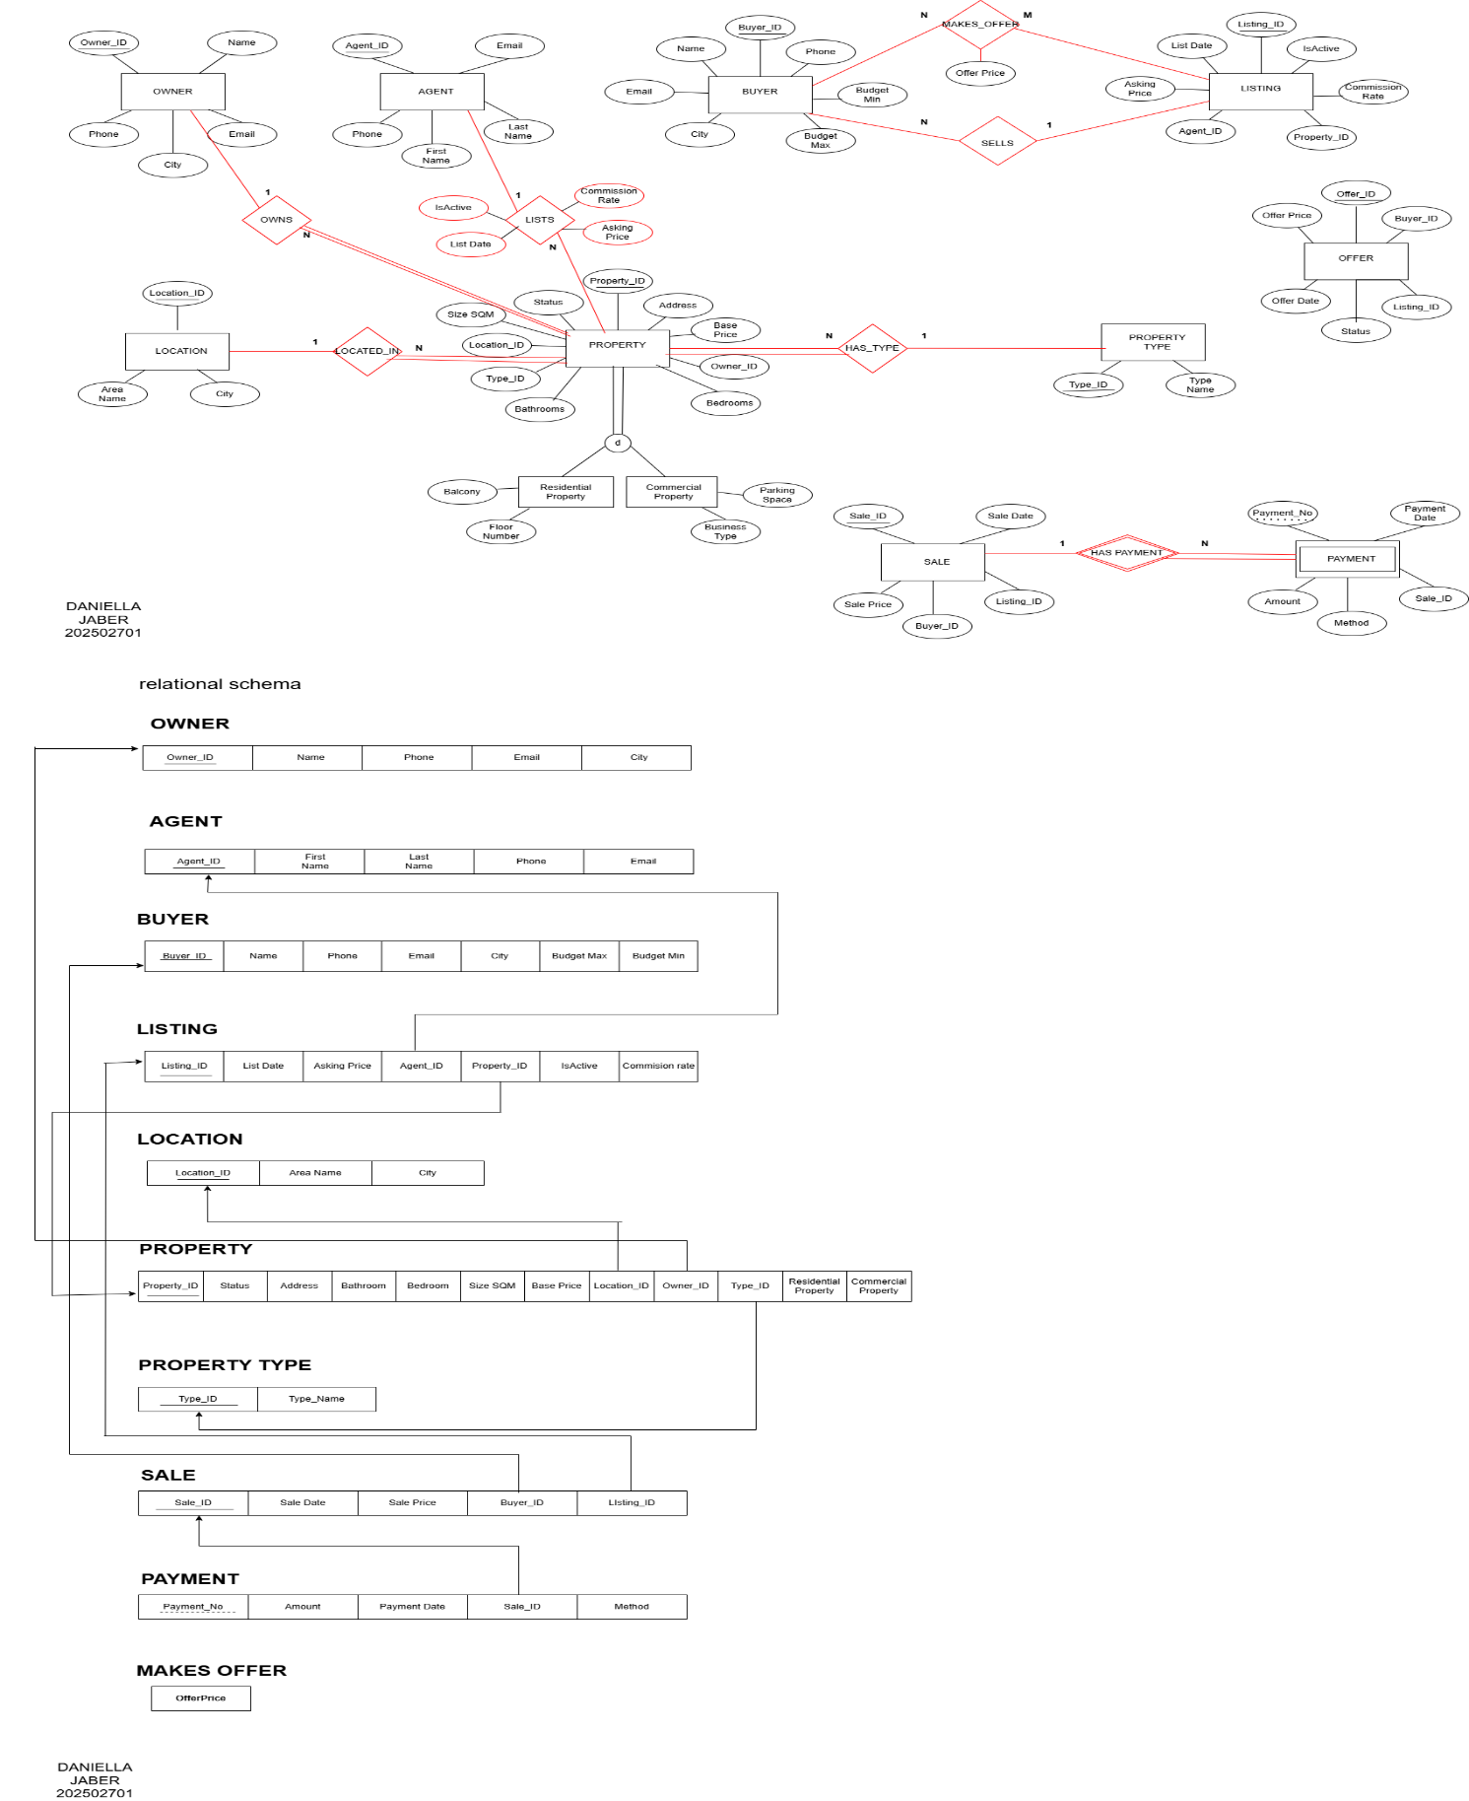

Relational Schema Tables

Owner
Attribute | Datatype | Format | Key Constraint | Referential Integrity | Entity Integrity
Owner_ID | INT | Max length 9 | Primary Key |  | Not Null
Name | String of characters | Max length 100 |  |  | Not Null
Phone | String of characters | Max length 50 |  |  | Not Null
Email | String of characters | Max length 100 | Unique |  | Not Null
City | String of characters | Max length 100 |  |  | Not Null

Location
Attribute | Datatype | Format | Key Constraint | Referential Integrity | Entity Integrity
Location_ID | INT | Max length 9 | Primary Key |  | Not Null
City | String of characters | Max length 100 |  |  | Not Null
Area_Name | String of characters | Max length 50 |  |  | Not Null

Attribute | Datatype | Format | Key Constraint | Referential Integrity | Entity Integrity
Type_ID | INT | Max length 9 | Primary Key |  | Not Null
Type_Name | String of characters | Max length 50 | Unique |  | Not Null

Property Type

Agent
Attribute | Datatype | Format | Key Constraint | Referential Integrity | Entity Integrity
Agent_ID | INT | Max length 9 | Primary Key |  | Not Null
First_Name | String of characters | Max length 50 |  |  | Not Null
Last_Name | String of characters | Max length 50 |  |  | Not Null
Phone | String of characters | Max length 50 |  |  | Not Null
Email | String of characters | Max length 100 | Unique |  | Not Null

Buyer
Attribute | Datatype | Format | Key Constraint | Referential Integrity | Entity Integrity
Buyer_ID | INT | Max length 9 | Primary Key |  | Not Null
Name | String of characters | Max length 50 |  |  | Not Null
Email | String of characters | Max length 100 |  |  | Not Null
City | String of characters | Max length 100 |  |  | Not Null
Budget_Min | INT | Max length 9 |  |  | Not Null
Budget_Max | INT | Max length 9 |  |  | Not Null

Property
Attribute | Datatype | Format | Key Constraint | Referential Integrity | Entity Integrity
Property_ID | INT | Max length 9 | Primary Key |  | Not Null
Address | String of characters | Max length 100 |  |  | Not Null
Size_SQM | INT | Max length 9 |  |  | Not Null
Bedrooms | INT | Max length 9 |  |  | Not Null
Bathrooms | INT | Max length 9 |  |  | Not Null
Base_Price | INT | Max length 9 |  |  | Not Null
Status | String of characters | Max length 20 |  |  | Not Null
Owner_ID | INT | Max length 9 |  | FK → Owner(Owner_ID), ON DELETE RESTRICT, ON UPDATE CASCADE | Not Null
Location_ID | INT | Max length 9 |  | FK → Location(Location_ID), ON DELETE RESTRICT, ON UPDATE CASCADE | Not Null
Type_ID | INT | Max length 9 |  | FK → Property_Type(Type_ID), ON DELETE RESTRICT, ON UPDATE CASCADE | Not Null

Listing
Attribute | Datatype | Format | Key Constraint | Referential Integrity | Entity Integrity
Listing_ID | INT | Max length 9 | Primary Key |  | Not Null
Property_ID | INT | Max length 9 |  | FK → Property(Property_ID), ON DELETE RESTRICT, ON UPDATE CASCADE | Not Null
Agent_ID | INT | Max length 9 |  | FK → Agent(Agent_ID), ON DELETE RESTRICT, ON UPDATE CASCADE | (can be Null)
List_Date | DATE | dd/mm/yyyy |  |  | Not Null
Asking_Price | INT | Max length 9 |  |  | Not Null
Commission_Rate | DECIMAL | 5,2 |  |  | Not Null
Is_Active | String of characters | Max length 1 |  |  | Not Null

Offer
Attribute | Datatype | Format | Key Constraint | Referential Integrity | Entity Integrity
Offer_ID | INT | Max length 9 | Primary Key |  | Not Null
Listing_ID | INT | Max length 9 |  | FK → Listing(Listing_ID), ON DELETE CASCADE, ON UPDATE CASCADE | Not Null
Buyer_ID | INT | Max length 9 |  | FK → Buyer(Buyer_ID), ON DELETE RESTRICT, ON UPDATE CASCADE | Not Null
Offer_Price | INT | Max length 9 |  |  | Not Null
Offer_Date | DATE | dd/mm/yyyy |  |  | Not Null
Status | String of characters | Max length 10 |  |  | Not Null

Sale
Attribute | Datatype | Format | Key Constraint | Referential Integrity | Entity Integrity
Sale_ID | INT | Max length 9 | Primary Key |  | Not Null
Listing_ID | INT | Max length 9 |  | FK → Listing(Listing_ID), ON DELETE CASCADE, ON UPDATE CASCADE | Not Null
Buyer_ID | INT | Max length 9 |  | FK → Buyer(Buyer_ID), ON DELETE RESTRICT, ON UPDATE CASCADE | Not Null
Sale_Date | DATE | dd/mm/yyyy |  |  | Not Null
Sale_Price | INT | Max length 9 |  |  | Not Null

Payment
Attribute | Datatype | Format | Key Constraint | Referential Integrity | Entity Integrity
Sale_ID | INT | Max length 9 | Primary Key | FK → Sale(Sale_ID), ON DELETE CASCADE, ON UPDATE CASCADE | Not Null
Payment_No | INT | Max length 9 |  |  | Not Null
Payment_Date | DATE | dd/mm/yyyy |  |  | Not Null
Amount | INT | Max length 9 |  |  | Not Null
Method | String of characters | Max length 20 |  |  | Not Null

OWNER TABLE
CREATE TABLE Owner (
Owner_ID INT NOT NULL PRIMARY KEY,
Name VARCHAR(100) NOT NULL ,
Phone VARCHAR(50) NOT NULL ,
Email VARCHAR(100) NOT NULL UNIQUE,
City VARCHAR(100) NOT NULL
);

INSERT INTO Owner (Owner_ID, Name, Phone, Email, City) VALUES
(1, 'Walid Mansour', '70123456', 'walid.mansour@gmail.com', 'Beirut'),
(2, 'Rita Issa', '76190822', 'rita.issa@gmail.com', 'Tripoli'),
(3, 'Fares Azar', '71120488', 'fares.azar@gmail.com', 'Saida'),
(4, 'Jad Saab', '76650211', 'jad.saab@gmail.com', 'Jounieh'),
(5, 'Elie Hachem', '81893344', 'elie.hachem@gmail.com', 'Byblos'),
(6, 'Jana Karam', '70882219', 'jana.karam@gmail.com', 'Dubai'),
(7, 'Mira Fares', '76994410', 'mira.fares@gmail.com', 'Zahle'),
(8, 'Nabil Bou Saab', '71900765', 'nabil.bousaab@gmail.com', 'Tyre'),
(9, 'Dalia Matar', '81003429', 'dalia.matar@gmail.com', 'Sidon'),
(10,'Tarek Kfoury', '70651234', 'tarek.kfoury@gmail.com', 'Baabda'),
(11,'Hassan El Hajj', '71668845', 'hassan.elhajj@gmail.com', 'Beirut'),
(12,'Lynn Nassar', '76671209', 'lynn.nassar@gmail.com', 'Tripoli'),
(13,'Ralph Sleiman', '70881117', 'ralph.sleiman@gmail.com', 'Saida'),
(14,'Samar Khoury', '71190223', 'samar.khoury@gmail.com', 'Jounieh'),
(15,'Hussein Fattouh', '76882014', 'hussein.fattouh@gmail.com', 'Byblos'),
(16,'Kamal Chami', '81145009', 'kamal.chami@gmail.com', 'Dubai'),
(17,'Dana Rahme', '71009876', 'dana.rahme@gmail.com', 'Zahle'),
(18,'Farah Atallah', '70997744', 'farah.atallah@gmail.com', 'Tyre'),
(19,'Zein Younes', '71886201', 'zein.younes@gmail.com', 'Sidon'),
(20,'Roy Harb', '71156400', 'roy.harb@gmail.com', 'Baabda'),
(21,'Nadia Mansour', '76992112', 'nadia.mansour@gmail.com', 'Beirut'),
(22,'Bassam Issa', '70118823', 'bassam.issa@gmail.com', 'Tripoli'),
(23,'Racha Azar', '76114007', 'racha.azar@gmail.com', 'Saida'),
(24,'Fadi Saab', '81662098', 'fadi.saab@gmail.com', 'Jounieh'),
(25,'Mona Hachem', '71883322', 'mona.hachem@gmail.com', 'Byblos'),
(26,'Rayan Karam', '76009443', 'rayan.karam@gmail.com', 'Dubai'),
(27,'Hala Fares', '71800221', 'hala.fares@gmail.com', 'Zahle'),
(28,'Amir Bou Saab', '70774412', 'amir.bousaab@gmail.com', 'Tyre'),
(29,'Yasmin Matar', '81770039', 'yasmin.matar@gmail.com', 'Sidon'),
(30,'Salim Kfoury', '76621033', 'salim.kfoury@gmail.com', 'Baabda'),
(31,'Bilal Hassan', '71114409', 'bilal.hassan@gmail.com', 'Beirut'),
(32,'Perla Nassar', '76992231', 'perla.nassar@gmail.com', 'Tripoli'),
(33,'Majd Sleiman', '70167145', 'majd.sleiman@gmail.com', 'Saida'),
(34,'Nadine Khoury', '71188302', 'nadine.khoury@gmail.com', 'Jounieh'),
(35,'Ziad Fattouh', '76882055', 'ziad.fattouh@gmail.com', 'Byblos'),
(36,'Layla Chami', '81670924', 'layla.chami@gmail.com', 'Dubai'),
(37,'Rita Rahme', '70990071', 'rita.rahme@gmail.com', 'Zahle'),
(38,'Mahmoud Atallah', '70183390', 'mahmoud.atallah@gmail.com', 'Tyre'),
(39,'Amal Younes', '71809431', 'amal.younes@gmail.com', 'Sidon'),
(40,'Ahmad Harb', '70657891', 'ahmad.harb@gmail.com', 'Baabda'),
(41,'Elissa Bou Saab', '71199044', 'elissa.bousaab@gmail.com', 'Beirut'),
(42,'Rima Issa', '81775006', 'rima.issa@gmail.com', 'Tripoli'),
(43,'Samir Azar', '72100349', 'samir.azar@gmail.com', 'Saida'),
(44,'Nancy Saab', '71661425', 'nancy.saab@gmail.com', 'Jounieh'),
(45,'Charbel Hachem', '70884401', 'charbel.hachem@gmail.com', 'Byblos'),
(46,'Lea Karam', '76008821', 'lea.karam@gmail.com', 'Dubai'),
(47,'Norah Fares', '70193024', 'norah.fares@gmail.com', 'Zahle'),
(48,'Rami Atallah', '76944211', 'rami.atallah@gmail.com', 'Tyre'),
(49,'Hiba Younes', '71990234', 'hiba.younes@gmail.com', 'Sidon'),
(50,'Marc Harb', '71120490', 'marc.harb@gmail.com', 'Baabda');

LOCATION TABLE
CREATE TABLE Location(
Location_ID INT NOT NULL PRIMARY KEY,
City VARCHAR(100) NOT NULL ,
Area_Name VARCHAR(50) NOT NULL
);
INSERT INTO Location (Location_ID, City, Area_Name) VALUES
(1, 'Beirut', 'Hamra'),
(2, 'Beirut', 'Achrafieh'),
(3, 'Beirut', 'Verdun'),
(4, 'Beirut', 'Mar Mikhael'),
(5, 'Beirut', 'Ain El Mreisseh'),
(6, 'Tripoli', 'Al Mina'),
(7, 'Tripoli', 'Bab El Tebbaneh'),
(8, 'Tripoli', 'Abu Samra'),
(9, 'Tripoli', 'Qobbeh'),
(10,'Tripoli', 'Zahrieh'),
(11,'Saida', 'Rmeileh'),
(12,'Saida', 'Haret Saida'),
(13,'Saida', 'Abra'),
(14,'Saida', 'Majdelyoun'),
(15,'Saida', 'Taamir'),
(16,'Tyre', 'Al Bass'),
(17,'Tyre', 'Abbassiyeh'),
(18,'Tyre', 'Borj El Shamali'),
(19,'Tyre', 'Qasmieh'),
(20,'Tyre', 'Rashidieh'),
(21,'Byblos', 'Aamchit'),
(22,'Byblos', 'Halat'),
(23,'Byblos', 'Blat'),
(24,'Byblos', 'Mechmech'),
(25,'Byblos', 'Fdar'),
(26,'Jounieh', 'Haret Sakher'),
(27,'Jounieh', 'Ghazir'),
(28,'Jounieh', 'Sarba'),
(29,'Jounieh', 'Maameltein'),
(30,'Jounieh', 'Adma'),
(31,'Zahle', 'Ksara'),
(32,'Zahle', 'Bouarij'),
(33,'Zahle', 'Taalabaya'),
(34,'Zahle', 'Qaa El Rim'),
(35,'Zahle', 'Houche Nouh'),
(36,'Baabda', 'Hazmieh'),
(37,'Baabda', 'Furn El Chebbak'),
(38,'Baabda', 'Louaizeh'),
(39,'Baabda', 'Araya'),
(40,'Baabda', 'Hadath'),
(41,'Sidon', 'Ain El Delb'),
(42,'Sidon', 'Ghaziyeh'),
(43,'Sidon', 'Haret Saida'),
(44,'Sidon', 'Majdelyoun'),
(45,'Sidon', 'Qraiye'),
(46,'Dubai', 'Marina'),
(47,'Dubai', 'Downtown'),
(48,'Dubai', 'Jumeirah'),
(49,'Dubai', 'Business Bay'),
(50,'Dubai', 'Palm Jumeirah');

PROPERTY TYPE TABLE
CREATE TABLE PropertyType(
Type_ID INT NOT NULL PRIMARY KEY,
Type_Name VARCHAR(50) NOT NULL UNIQUE
);

INSERT INTO PropertyType (Type_ID, Type_Name) VALUES
(1, 'Apartment'),
(2, 'Villa'),
(3, 'Studio'),
(4, 'Penthouse'),
(5, 'Duplex'),
(6, 'Townhouse'),
(7, 'Office Space'),
(8, 'Retail Shop'),
(9, 'Warehouse'),
(10, 'Land'),
(11, 'Chalet'),
(12, 'Bungalow'),
(13, 'Loft'),
(14, 'Mansion'),
(15, 'Farmhouse'),
(16, 'Cottage'),
(17, 'Commercial Building'),
(18, 'Industrial Plot'),
(19, 'Hotel Suite'),
(20, 'Resort Unit'),
(21, 'Serviced Apartment'),
(22, 'Detached House'),
(23, 'Semi-Detached House'),
(24, 'Row House'),
(25, 'Beachfront Villa'),
(26, 'Mountain Cabin'),
(27, 'Residential Plot'),
(28, 'Office Floor'),
(29, 'Medical Clinic'),
(30, 'Showroom'),
(31, 'Food Court Unit'),
(32, 'Restaurant Space'),
(33, 'Gym Facility'),
(34, 'Education Center'),
(35, 'Storage Unit'),
(36, 'Farm Land'),
(37, 'Agricultural Warehouse'),
(38, 'Holiday Home'),
(39, 'Basement Unit'),
(40, 'Rooftop Unit'),
(41, 'Parking Space'),
(42, 'Car Dealership Space'),
(43, 'Supermarket Unit'),
(44, 'Boutique Shop'),
(45, 'Luxury Penthouse'),
(46, 'Smart Apartment'),
(47, 'High-Rise Unit'),
(48, 'Low-Rise Unit'),
(49, 'Investment Property'),
(50, 'Mixed-Use Space');

AGENT TABLE
CREATE TABLE Agent (
Agent_ID INT NOT NULL PRIMARY KEY ,
First_Name VARCHAR(50) NOT NULL,
Last_Name VARCHAR (50) NOT NULL ,
Phone VARCHAR(50) NOT NULL,
Email VARCHAR(100) NOT NULL UNIQUE
);
INSERT INTO Agent (Agent_ID, First_Name, Last_Name, Phone, Email) VALUES
(1, 'Ralph', 'Bou Saab', '76123011', 'ralph.bousaab@gmail.com'),
(2, 'Tala', 'Matar', '71190223', 'tala.matar@gmail.com'),
(3, 'Adel', 'Kfoury', '70881117', 'adel.kfoury@gmail.com'),
(4, 'Zoe', 'Khoury', '70155498', 'zoe.khoury@gmail.com'),
(5, 'Yasmin', 'Hassan', '76671209', 'yasmin.hassan@gmail.com'),
(6, 'Samir', 'Nassar', '71104482', 'samir.nassar@gmail.com'),
(7, 'Perla', 'Rahme', '71900765', 'perla.rahme@gmail.com'),
(8, 'Majd', 'Atallah', '81893344', 'majd.atallah@gmail.com'),
(9, 'Nada', 'Younes', '70651234', 'nada.younes@gmail.com'),
(10, 'Fadi', 'Harb', '76882014', 'fadi.harb@gmail.com'),
(11, 'Karim', 'Saleh', '71661425', 'karim.saleh@gmail.com'),
(12, 'Lynn', 'Yousef', '71120490', 'lynn.yousef@gmail.com'),
(13, 'Zein', 'Karam', '70100887', 'zein.karam@gmail.com'),
(14, 'Mona', 'Fares', '76190822', 'mona.fares@gmail.com'),
(15, 'Rayan', 'Hachem', '76994410', 'rayan.hachem@gmail.com'),
(16, 'Hala', 'Saba', '70882219', 'hala.saba@gmail.com'),
(17, 'Amir', 'Mansour', '71990234', 'amir.mansour@gmail.com'),
(18, 'Salim', 'Issa', '76650211', 'salim.issa@gmail.com'),
(19, 'Bilal', 'Azar', '71188302', 'bilal.azar@gmail.com'),
(20, 'Nadine', 'Saab', '81800221', 'nadine.saab@gmail.com'),
(21, 'Mahmoud', 'Bou Saab', '70123489', 'mahmoud.bousaab@gmail.com'),
(22, 'Layla', 'Matar', '76009443', 'layla.matar@gmail.com'),
(23, 'Ahmad', 'Kfoury', '81770039', 'ahmad.kfoury@gmail.com'),
(24, 'Dana', 'Khoury', '76944211', 'dana.khoury@gmail.com'),
(25, 'Farah', 'Hassan', '70774412', 'farah.hassan@gmail.com'),
(26, 'Ziad', 'Nassar', '70118823', 'ziad.nassar@gmail.com'),
(27, 'Roy', 'Rahme', '71886201', 'roy.rahme@gmail.com'),
(28, 'Hussein', 'Atallah', '70997744', 'hussein.atallah@gmail.com'),
(29, 'Kamal', 'Younes', '81145009', 'kamal.younes@gmail.com'),
(30, 'Sahar', 'Harb', '70167145', 'sahar.harb@gmail.com'),
(31, 'Racha', 'Saleh', '71883322', 'racha.saleh@gmail.com'),
(32, 'Bassam', 'Yousef', '71114409', 'bassam.yousef@gmail.com'),
(33, 'Hiba', 'Karam', '76114007', 'hiba.karam@gmail.com'),
(34, 'Nour', 'Fares', '71668845', 'nour.fares@gmail.com'),
(35, 'Elie', 'Hachem', '70884401', 'elie.hachem@gmail.com'),
(36, 'Tarek', 'Saba', '76008821', 'tarek.saba@gmail.com'),
(37, 'Lea', 'Mansour', '76992231', 'lea.mansour@gmail.com'),
(38, 'Youssef', 'Issa', '71900788', 'youssef.issa@gmail.com'),
(39, 'Rawan', 'Azar', '76621033', 'rawan.azar@gmail.com'),
(40, 'Malak', 'Saab', '70193024', 'malak.saab@gmail.com'),
(41, 'Elissa', 'Bou Saab', '71199044', 'elissa.bousaab@gmail.com'),
(42, 'Rima', 'Issa', '81775006', 'rima.issa@gmail.com'),
(43, 'Samir', 'Azar', '72100349', 'samir.azar@gmail.com'),
(44, 'Nancy', 'Saab', '71661488', 'nancy.saab@gmail.com'),
(45, 'Charbel', 'Hachem', '70885521', 'charbel.hachem@gmail.com'),
(46, 'Lea', 'Karam', '76001132', 'lea.karam@gmail.com'),
(47, 'Norah', 'Fares', '70124499', 'norah.fares@gmail.com'),
(48, 'Rami', 'Atallah', '76993321', 'rami.atallah@gmail.com'),
(49, 'Hiba', 'Younes', '71155678', 'hiba.younes@gmail.com'),
(50, 'Marc', 'Harb', '76687112', 'marc.harb@gmail.com');

BUYER TABLE
CREATE TABLE Buyer (
Buyer_ID INT NOT NULL PRIMARY KEY,
Name VARCHAR(50) NOT NULL ,
Email VARCHAR(100) NOT NULL,
City VARCHAR(100) NOT NULL,
Budget_Min INT NOT NULL CHECK(Budget_Min >=0),
Budget_Max INT NOT NULL CHECK (Budget_Max >= Budget_Min)
);
INSERT INTO Buyer (Buyer_ID, Name, Email, City, Budget_Min, Budget_Max) VALUES
(1, 'Karim Mansour', 'karim.mansour@gmail.com', 'Beirut', 60000, 120000),
(2, 'Rita Khoury', 'rita.khoury@gmail.com', 'Jounieh', 80000, 150000),
(3, 'Jad Harb', 'jad.harb@gmail.com', 'Baabda', 50000, 110000),
(4, 'Nour Younes', 'nour.younes@gmail.com', 'Tripoli', 40000, 90000),
(5, 'Fadi Saab', 'fadi.saab@gmail.com', 'Sidon', 70000, 130000),
(6, 'Lynn Issa', 'lynn.issa@gmail.com', 'Byblos', 90000, 180000),
(7, 'Elie Atallah', 'elie.atallah@gmail.com', 'Beirut', 100000, 200000),
(8, 'Dalia Matar', 'dalia.matar@gmail.com', 'Zahle', 45000, 95000),
(9, 'Hussein Chami', 'hussein.chami@gmail.com', 'Tyre', 30000, 85000),
(10, 'Perla Fares', 'perla.fares@gmail.com', 'Saida', 60000, 140000),
(11, 'Nabil Sleiman', 'nabil.sleiman@gmail.com', 'Beirut', 120000, 250000),
(12, 'Sarah Karam', 'sarah.karam@gmail.com', 'Dubai', 150000, 300000),
(13, 'Rayan Bou Saab', 'rayan.bousaab@gmail.com', 'Tripoli', 50000, 100000),
(14, 'Maya Hassan', 'maya.hassan@gmail.com', 'Byblos', 70000, 170000),
(15, 'Samir Azar', 'samir.azar@gmail.com', 'Jounieh', 55000, 125000),
(16, 'Tala Rahme', 'tala.rahme@gmail.com', 'Beirut', 90000, 160000),
(17, 'Ahmad Mansour', 'ahmad.mansour@gmail.com', 'Baabda', 40000, 100000),
(18, 'Roy Fattouh', 'roy.fattouh@gmail.com', 'Zahle', 65000, 140000),
(19, 'Nadine Issa', 'nadine.issa@gmail.com', 'Saida', 80000, 180000),
(20, 'Kamal Younes', 'kamal.younes@gmail.com', 'Tripoli', 30000, 70000),
(21, 'Lea Harb', 'lea.harb@gmail.com', 'Beirut', 95000, 200000),
(22, 'Mahmoud Kfoury', 'mahmoud.kfoury@gmail.com', 'Tyre', 35000, 90000),
(23, 'Dana Sleiman', 'dana.sleiman@gmail.com', 'Jounieh', 60000, 150000),
(24, 'Farah Chami', 'farah.chami@gmail.com', 'Baabda', 70000, 140000),
(25, 'Bilal Atallah', 'bilal.atallah@gmail.com', 'Tripoli', 45000, 110000),
(26, 'Rita Mansour', 'rita.mansour@gmail.com', 'Dubai', 100000, 250000),
(27, 'Tarek Khoury', 'tarek.khoury@gmail.com', 'Beirut', 70000, 160000),
(28, 'Jana Fares', 'jana.fares@gmail.com', 'Byblos', 90000, 180000),
(29, 'Marc Azar', 'marc.azar@gmail.com', 'Sidon', 60000, 130000),
(30, 'Yasmin Rahme', 'yasmin.rahme@gmail.com', 'Zahle', 40000, 85000),
(31, 'Elissa Nassar', 'elissa.nassar@gmail.com', 'Beirut', 120000, 220000),
(32, 'Rami Sleiman', 'rami.sleiman@gmail.com', 'Jounieh', 50000, 120000),
(33, 'Amal Younes', 'amal.younes@gmail.com', 'Tripoli', 30000, 90000),
(34, 'Charbel Hage', 'charbel.hage@gmail.com', 'Byblos', 100000, 210000),
(35, 'Nour Saad', 'nour.saad@gmail.com', 'Saida', 70000, 155000),
(36, 'Hiba Mansour', 'hiba.mansour@gmail.com', 'Baabda', 95000, 190000),
(37, 'Elias Karam', 'elias.karam@gmail.com', 'Tyre', 60000, 130000),
(38, 'Rana Hassan', 'rana.hassan@gmail.com', 'Beirut', 80000, 160000),
(39, 'Ziad Chami', 'ziad.chami@gmail.com', 'Zahle', 40000, 100000),
(40, 'Mira Fattouh', 'mira.fattouh@gmail.com', 'Tripoli', 45000, 110000),
(41, 'Adel Bou Saab', 'adel.bousaab@gmail.com', 'Dubai', 150000, 300000),
(42, 'Samar Harb', 'samar.harb@gmail.com', 'Beirut', 100000, 200000),
(43, 'Hana Sleiman', 'hana.sleiman@gmail.com', 'Byblos', 55000, 120000),
(44, 'Youssef Atallah', 'youssef.atallah@gmail.com', 'Saida', 75000, 150000),
(45, 'Mona Rahme', 'mona.rahme@gmail.com', 'Baabda', 65000, 130000),
(46, 'Naji Mansour', 'naji.mansour@gmail.com', 'Tripoli', 70000, 145000),
(47, 'Rola Khoury', 'rola.khoury@gmail.com', 'Jounieh', 60000, 140000),
(48, 'Hassan Karam', 'hassan.karam@gmail.com', 'Sidon', 40000, 100000),
(49, 'Layal Fares', 'layal.fares@gmail.com', 'Beirut', 90000, 185000),
(50, 'Issam Azar', 'issam.azar@gmail.com', 'Tyre', 30000, 80000);

PROPERTY TABLE
CREATE TABLE Property (
Property_ID INT NOT NULL PRIMARY KEY ,
Address VARCHAR(100) NOT NULL,
Size_SQM INT NOT NULL CHECK(Size_SQM > 0),
Bedrooms INT NOT NULL CHECK(Bedrooms >0),
Bathrooms INT NOT NULL CHECK(Bathrooms >=0),
Base_Price INT NOT NULL CHECK(Base_Price >0),
Status VARCHAR(20) NOT NULL DEFAULT 'Available ' CHECK( Status IN ('Available','UnderOffer','Sold')),
Owner_ID INT NOT NULL ,
Location_ID INT NOT NULL ,
Type_ID INT NOT NULL,
FOREIGN KEY (Owner_ID ) REFERENCES Owner(Owner_ID) ON DELETE CASCADE ON UPDATE CASCADE,
FOREIGN KEY (Location_ID ) REFERENCES Location(Location_ID) ON DELETE RESTRICT ON UPDATE CASCADE,
FOREIGN KEY (Type_ID ) REFERENCES PropertyType(Type_ID) ON DELETE RESTRICT ON UPDATE CASCADE
);

INSERT INTO Property (Property_ID, Address, Size_SQM, Bedrooms, Bathrooms, Base_Price, Status, Owner_ID, Location_ID, Type_ID) VALUES
(1, '12 Hamra Street, Beirut', 120, 3, 2, 185000, 'Available', 1, 1, 1),
(2, '44 Achrafieh Main Road, Beirut', 95, 2, 1, 150000, 'Available', 2, 2, 3),
(3, '88 Verdun Towers, Beirut', 210, 4, 3, 420000, 'UnderOffer', 3, 3, 5),
(4, '7 Mar Mikhael Loft, Beirut', 65, 1, 1, 130000, 'Available', 4, 4, 13),
(5, '22 Ain El Mreisseh Seaview, Beirut', 300, 5, 4, 750000, 'Sold', 5, 5, 4),
(6, '18 Al Mina Street, Tripoli', 140, 3, 2, 170000, 'Available', 6, 6, 1),
(7, '55 Bab El Tebbaneh Complex, Tripoli', 80, 2, 1, 90000, 'Available', 7, 7, 3),
(8, '100 Abu Samra Heights, Tripoli', 160, 3, 2, 210000, 'UnderOffer', 8, 8, 7),
(9, '29 Qobbeh Residences, Tripoli', 110, 2, 2, 145000, 'Available', 9, 9, 22),
(10, '60 Zahrieh Central, Tripoli', 180, 4, 3, 250000, 'Sold', 10, 10, 11),
(11, '12 Rmeileh Block, Saida', 125, 3, 2, 160000, 'Available', 11, 11, 1),
(12, '32 Haret Saida Lane, Saida', 210, 4, 3, 280000, 'UnderOffer', 12, 12, 2),
(13, '47 Abra Residence, Saida', 95, 2, 1, 100000, 'Available', 13, 13, 3),
(14, '89 Majdelyoun View, Saida', 170, 3, 2, 200000, 'Available', 14, 14, 25),
(15, '77 Taamir Boulevard, Saida', 140, 3, 2, 175000, 'Sold', 15, 15, 8),
(16, '11 Al Bass Road, Tyre', 200, 4, 3, 300000, 'Available', 16, 16, 2),
(17, '92 Abbassiyeh Gardens, Tyre', 130, 3, 2, 160000, 'UnderOffer', 17, 17, 5),
(18, '58 Borj El Shamali Phase 2, Tyre', 85, 2, 1, 90000, 'Available', 18, 18, 3),
(19, '40 Qasmieh Riverside, Tyre', 260, 5, 4, 450000, 'Sold', 19, 19, 14),
(20, '35 Rashidieh Homes, Tyre', 115, 2, 2, 130000, 'Available', 20, 20, 1),
(21, '12 Aamchit Villas, Byblos', 215, 4, 3, 350000, 'Available', 21, 21, 2),
(22, '80 Halat Seaside, Byblos', 95, 2, 1, 140000, 'Available', 22, 22, 3),
(23, '66 Blat Residences, Byblos', 175, 3, 2, 230000, 'UnderOffer', 23, 23, 5),
(24, '23 Mechmech Heights, Byblos', 320, 5, 4, 500000, 'Available', 24, 24, 2),
(25, '51 Fidar Hill, Byblos', 110, 2, 2, 155000, 'Sold', 25, 25, 7),
(26, '19 Haret Sakher Block A, Jounieh', 145, 3, 2, 210000, 'Available', 26, 26, 1),
(27, '87 Ghazir Mountain View, Jounieh', 250, 4, 3, 390000, 'UnderOffer', 27, 27, 2),
(28, '30 Sarba Residential, Jounieh', 90, 2, 1, 120000, 'Available', 28, 28, 3),
(29, '95 Maameltein Suites, Jounieh', 180, 3, 2, 240000, 'Available', 29, 29, 21),
(30, '48 Adma Hills, Jounieh', 300, 5, 4, 600000, 'Sold', 30, 30, 4),
(31, '5 Ksara Wine Valley, Zahle', 140, 3, 2, 165000, 'Available', 31, 31, 1),
(32, '77 Bouarij North, Zahle', 110, 2, 2, 130000, 'UnderOffer', 32, 32, 3),
(33, '33 Taalabaya Towers, Zahle', 200, 4, 3, 310000, 'Available', 33, 33, 7),
(34, '14 Qaa El Rim Scenic Road, Zahle', 155, 3, 2, 190000, 'Available', 34, 34, 22),
(35, '90 Houche Nouh Avenue, Zahle', 100, 2, 1, 115000, 'Sold', 35, 35, 8),
(36, '22 Hazmieh Boulevard, Baabda', 125, 3, 2, 185000, 'Available', 36, 36, 1),
(37, '60 Furn El Chebbak Central, Baabda', 165, 3, 2, 220000, 'UnderOffer', 37, 37, 5),
(38, '44 Louaizeh Gardens, Baabda', 90, 2, 1, 125000, 'Available', 38, 38, 3),
(39, '17 Araya Ridge, Baabda', 240, 4, 3, 350000, 'Available', 39, 39, 2),
(40, '88 Hadath Green Zone, Baabda', 310, 5, 4, 520000, 'Sold', 40, 40, 11),
(41, '9 Ain El Delb Village, Sidon', 150, 3, 2, 175000, 'Available', 41, 41, 1),
(42, '33 Ghaziyeh Complex, Sidon', 130, 3, 2, 160000, 'UnderOffer', 42, 42, 3),
(43, '14 Haret Saida Homes, Sidon', 180, 4, 3, 260000, 'Available', 43, 43, 5),
(44, '59 Majdelyoun Valley, Sidon', 210, 4, 3, 310000, 'Available', 44, 44, 2),
(45, '70 Qraiye District, Sidon', 95, 2, 1, 100000, 'Sold', 45, 45, 7),
(46, '121 Marina Towers, Dubai', 350, 5, 4, 950000, 'Available', 46, 46, 4),
(47, '10 Downtown Residences, Dubai', 190, 3, 2, 600000, 'UnderOffer', 47, 47, 21),
(48, '50 Jumeirah Beach Road, Dubai', 220, 4, 3, 750000, 'Available', 48, 48, 2),
(49, '88 Business Bay Tower, Dubai', 160, 3, 2, 500000, 'Available', 49, 49, 1),
(50, '32 Palm Jumeirah Villas, Dubai', 450, 6, 5, 1500000, 'Sold', 50, 50, 2);

LISTING TABLE
CREATE TABLE Listing (
Listing_id INT NOT NULL PRIMARY KEY ,
Property_ID INT NOT NULL ,
Agent_ID INT NULL ,
List_Date DATE NOT NULL ,
Asking_Price INT NOT NULL CHECK( Asking_Price>0),
Commission_Rate DECIMAL(5,2) NOT NULL CHECK (Commission_Rate >= 0 AND Commission_Rate <= 100),
Is_Active CHAR(1) NOT NULL DEFAULT 'Y' CHECK( Is_Active IN ('Y' ,'N')),
FOREIGN KEY (Property_ID) REFERENCES Property(Property_ID) ON DELETE CASCADE ON UPDATE CASCADE,
FOREIGN KEY (Agent_ID) REFERENCES Agent(Agent_ID) ON DELETE SET NULL ON UPDATE CASCADE
);
INSERT INTO Listing (Listing_ID, Property_ID, Agent_ID, List_Date, Asking_Price, Commission_Rate, Is_Active) VALUES
(1, 1, 5, '2024-01-10', 190000, 2.50, 'Y'),
(2, 2, 8, '2024-01-15', 155000, 2.00, 'Y'),
(3, 3, 12, '2024-01-20', 435000, 3.00, 'Y'),
(4, 4, 3, '2024-01-25', 135000, 2.25, 'Y'),
(5, 5, 10, '2024-02-01', 770000, 3.50, 'N'),
(6, 6, 6, '2024-02-05', 175000, 2.25, 'Y'),
(7, 7, 9, '2024-02-10', 95000, 1.75, 'Y'),
(8, 8, 14, '2024-02-15', 220000, 3.00, 'Y'),
(9, 9, 2, '2024-02-18', 150000, 2.00, 'Y'),
(10, 10, 18, '2024-02-20', 260000, 3.25, 'N'),
(11, 11, 7, '2024-02-25', 165000, 2.50, 'Y'),
(12, 12, 11, '2024-03-01', 290000, 3.00, 'Y'),
(13, 13, 4, '2024-03-05', 105000, 1.80, 'Y'),
(14, 14, 13, '2024-03-10', 210000, 2.75, 'Y'),
(15, 15, 16, '2024-03-15', 185000, 2.50, 'N'),
(16, 16, 20, '2024-03-20', 310000, 3.00, 'Y'),
(17, 17, 1, '2024-03-22', 170000, 2.25, 'Y'),
(18, 18, 19, '2024-03-25', 95000, 1.90, 'Y'),
(19, 19, 22, '2024-03-28', 470000, 3.75, 'N'),
(20, 20, 15, '2024-04-01', 140000, 2.00, 'Y'),
(21, 21, 9, '2024-04-05', 360000, 3.00, 'Y'),
(22, 22, 6, '2024-04-08', 150000, 2.10, 'Y'),
(23, 23, 24, '2024-04-10', 240000, 2.80, 'Y'),
(24, 24, 25, '2024-04-15', 520000, 3.50, 'Y'),
(25, 25, 3, '2024-04-18', 165000, 2.30, 'N'),
(26, 26, 28, '2024-04-20', 220000, 2.60, 'Y'),
(27, 27, 30, '2024-04-25', 405000, 3.10, 'Y'),
(28, 28, 17, '2024-04-28', 125000, 2.00, 'Y'),
(29, 29, 21, '2024-05-01', 250000, 2.90, 'Y'),
(30, 30, 26, '2024-05-05', 620000, 3.80, 'N'),
(31, 31, 32, '2024-05-10', 175000, 2.40, 'Y'),
(32, 32, 11, '2024-05-12', 135000, 2.00, 'Y'),
(33, 33, 35, '2024-05-15', 320000, 3.20, 'Y'),
(34, 34, 29, '2024-05-18', 200000, 2.70, 'Y'),
(35, 35, 5, '2024-05-20', 120000, 1.95, 'N'),
(36, 36, 7, '2024-05-25', 195000, 2.50, 'Y'),
(37, 37, 40, '2024-05-28', 230000, 2.80, 'Y'),
(38, 38, 34, '2024-06-01', 130000, 2.10, 'Y'),
(39, 39, 38, '2024-06-03', 360000, 3.00, 'Y'),
(40, 40, 42, '2024-06-05', 540000, 3.70, 'N'),
(41, 41, 10, '2024-06-10', 185000, 2.35, 'Y'),
(42, 42, 14, '2024-06-12', 170000, 2.20, 'Y'),
(43, 43, 18, '2024-06-15', 270000, 3.10, 'Y'),
(44, 44, 23, '2024-06-18', 330000, 3.30, 'Y'),
(45, 45, 27, '2024-06-20', 110000, 1.85, 'N'),
(46, 46, 31, '2024-06-25', 980000, 4.00, 'Y'),
(47, 47, 36, '2024-06-28', 620000, 3.50, 'Y'),
(48, 48, 44, '2024-07-01', 770000, 3.80, 'Y'),
(49, 49, 48, '2024-07-03', 520000, 3.20, 'Y'),
(50, 50, 50, '2024-07-05', 1550000, 4.00, 'N');

OFFER TABLE
CREATE TABLE Offer (
Offer_ID INT NOT NULL PRIMARY KEY,
Listing_ID INT NOT NULL,
Buyer_ID INT NOT NULL ,
Offer_Price INT NOT NULL CHECK(Offer_Price >0),
Offer_Date DATE NOT NULL ,
Status VARCHAR(10) NOT NULL CHECK(Status IN ('Pending','Accepted','Rejected')),
FOREIGN KEY (Listing_ID) REFERENCES Listing(Listing_ID) ON DELETE CASCADE ON UPDATE CASCADE,
FOREIGN KEY (Buyer_ID) REFERENCES Buyer(Buyer_ID) ON DELETE CASCADE ON UPDATE CASCADE
);
INSERT INTO Offer (Offer_ID, Listing_ID, Buyer_ID, Offer_Price, Offer_Date, Status) VALUES
(1, 1, 10, 180000, '2024-02-01', 'Pending'),
(2, 2, 4, 150000, '2024-02-03', 'Rejected'),
(3, 3, 15, 440000, '2024-02-06', 'Accepted'),
(4, 4, 22, 130000, '2024-02-10', 'Pending'),
(5, 5, 8, 760000, '2024-02-12', 'Rejected'),
(6, 6, 30, 170000, '2024-02-14', 'Pending'),
(7, 7, 12, 90000, '2024-02-18', 'Accepted'),
(8, 8, 27, 215000, '2024-02-20', 'Rejected'),
(9, 9, 3, 152000, '2024-02-22', 'Pending'),
(10, 10, 18, 255000, '2024-02-26', 'Accepted'),
(11, 11, 25, 160000, '2024-03-01', 'Pending'),
(12, 12, 39, 295000, '2024-03-05', 'Rejected'),
(13, 13, 7, 98000, '2024-03-06', 'Pending'),
(14, 14, 20, 205000, '2024-03-10', 'Accepted'),
(15, 15, 31, 180000, '2024-03-12', 'Rejected'),
(16, 16, 49, 305000, '2024-03-15', 'Pending'),
(17, 17, 14, 165000, '2024-03-18', 'Accepted'),
(18, 18, 33, 92000, '2024-03-19', 'Rejected'),
(19, 19, 21, 460000, '2024-03-22', 'Pending'),
(20, 20, 11, 135000, '2024-03-25', 'Accepted'),
(21, 21, 5, 350000, '2024-04-01', 'Pending'),
(22, 22, 41, 148000, '2024-04-03', 'Rejected'),
(23, 23, 1, 250000, '2024-04-05', 'Pending'),
(24, 24, 26, 515000, '2024-04-07', 'Accepted'),
(25, 25, 34, 160000, '2024-04-10', 'Rejected'),
(26, 26, 48, 215000, '2024-04-13', 'Pending'),
(27, 27, 9, 400000, '2024-04-15', 'Accepted'),
(28, 28, 16, 120000, '2024-04-17', 'Pending'),
(29, 29, 35, 245000, '2024-04-20', 'Rejected'),
(30, 30, 2, 610000, '2024-04-22', 'Accepted'),
(31, 31, 40, 170000, '2024-05-01', 'Pending'),
(32, 32, 19, 130000, '2024-05-03', 'Rejected'),
(33, 33, 45, 315000, '2024-05-04', 'Pending'),
(34, 34, 6, 195000, '2024-05-07', 'Accepted'),
(35, 35, 36, 118000, '2024-05-10', 'Rejected'),
(36, 36, 29, 190000, '2024-05-12', 'Pending'),
(37, 37, 23, 225000, '2024-05-14', 'Accepted'),
(38, 38, 17, 128000, '2024-05-15', 'Pending'),
(39, 39, 28, 365000, '2024-05-18', 'Rejected'),
(40, 40, 43, 530000, '2024-05-20', 'Accepted'),
(41, 41, 50, 180000, '2024-06-01', 'Pending'),
(42, 42, 24, 165000, '2024-06-03', 'Accepted'),
(43, 43, 37, 260000, '2024-06-05', 'Rejected'),
(44, 44, 32, 325000, '2024-06-07', 'Pending'),
(45, 45, 46, 108000, '2024-06-10', 'Rejected'),
(46, 46, 13, 950000, '2024-06-12', 'Pending'),
(47, 47, 4, 615000, '2024-06-14', 'Accepted'),
(48, 48, 22, 760000, '2024-06-16', 'Rejected'),
(49, 49, 38, 510000, '2024-06-17', 'Pending'),
(50, 50, 44, 1520000, '2024-06-20', 'Accepted');

SALE TABLE
CREATE TABLE Sale (
Sale_ID INT NOT NULL PRIMARY KEY,
Listing_ID INT NOT NULL ,
Buyer_ID INT NOT NULL ,
Sale_Date DATE NOT NULL ,
Sale_Price INT NOT NULL CHECK(Sale_Price>0),
FOREIGN KEY (Listing_ID) REFERENCES Listing(Listing_ID) ON DELETE CASCADE ON UPDATE CASCADE,
FOREIGN KEY (Buyer_ID) REFERENCES Buyer(Buyer_ID) ON DELETE CASCADE ON UPDATE CASCADE
);

INSERT INTO Sale (Sale_ID, Listing_ID, Buyer_ID, Sale_Date, Sale_Price) VALUES
(1, 1, 1, '2024-08-01', 190000),
(2, 2, 2, '2024-08-02', 155000),
(3, 3, 3, '2024-08-03', 435000),
(4, 4, 4, '2024-08-04', 135000),
(5, 5, 5, '2024-08-05', 770000),
(6, 6, 6, '2024-08-06', 175000),
(7, 7, 7, '2024-08-07', 95000),
(8, 8, 8, '2024-08-08', 220000),
(9, 9, 9, '2024-08-09', 150000),
(10, 10, 10, '2024-08-10', 260000),
(11, 11, 11, '2024-08-11', 165000),
(12, 12, 12, '2024-08-12', 290000),
(13, 13, 13, '2024-08-13', 105000),
(14, 14, 14, '2024-08-14', 210000),
(15, 15, 15, '2024-08-15', 180000),
(16, 16, 16, '2024-08-16', 310000),
(17, 17, 17, '2024-08-17', 170000),
(18, 18, 18, '2024-08-18', 95000),
(19, 19, 19, '2024-08-19', 460000),
(20, 20, 20, '2024-08-20', 140000),
(21, 21, 21, '2024-08-21', 350000),
(22, 22, 22, '2024-08-22', 150000),
(23, 23, 23, '2024-08-23', 250000),
(24, 24, 24, '2024-08-24', 515000),
(25, 25, 25, '2024-08-25', 160000),
(26, 26, 26, '2024-08-26', 215000),
(27, 27, 27, '2024-08-27', 400000),
(28, 28, 28, '2024-08-28', 120000),
(29, 29, 29, '2024-08-29', 245000),
(30, 30, 30, '2024-08-30', 620000),
(31, 31, 31, '2024-08-31', 175000),
(32, 32, 32, '2024-09-01', 135000),
(33, 33, 33, '2024-09-02', 320000),
(34, 34, 34, '2024-09-03', 200000),
(35, 35, 35, '2024-09-04', 120000),
(36, 36, 36, '2024-09-05', 195000),
(37, 37, 37, '2024-09-06', 230000),
(38, 38, 38, '2024-09-07', 130000),
(39, 39, 39, '2024-09-08', 360000),
(40, 40, 40, '2024-09-09', 540000),
(41, 41, 41, '2024-09-10', 185000),
(42, 42, 42, '2024-09-11', 170000),
(43, 43, 43, '2024-09-12', 270000),
(44, 44, 44, '2024-09-13', 330000),
(45, 45, 45, '2024-09-14', 110000),
(46, 46, 46, '2024-09-15', 980000),
(47, 47, 47, '2024-09-16', 620000),
(48, 48, 48, '2024-09-17', 770000),
(49, 49, 49, '2024-09-18', 520000),
(50, 50, 50, '2024-09-19', 1550000);

PAYMENT TABLE
CREATE TABLE Payment(
Sale_ID INT NOT NULL ,
Payment_No INT NOT NULL ,
Payment_Date DATE NOT NULL ,
Amount INT NOT NULL CHECK(Amount>0),
Method VARCHAR(20) NOT NULL CHECK (Method IN ('Cash','Transfer','Installment')),
PRIMARY KEY (Sale_ID, Payment_No),
FOREIGN KEY (Sale_ID) REFERENCES Sale(Sale_ID) ON DELETE CASCADE ON UPDATE CASCADE
);
INSERT INTO Payment (Sale_ID, Payment_No, Payment_Date, Amount, Method) VALUES
(1, 1, '2024-08-05', 90000, 'Transfer'),
(1, 2, '2024-08-20', 100000, 'Cash'),
(2, 1, '2024-08-06', 60000, 'Cash'),
(2, 2, '2024-08-25', 95000, 'Transfer'),
(3, 1, '2024-08-07', 130000, 'Installment'),
(3, 2, '2024-08-25', 125000, 'Cash'),
(4, 1, '2024-08-08', 70000, 'Transfer'),
(4, 2, '2024-08-22', 65000, 'Cash'),
(5, 1, '2024-08-09', 350000, 'Transfer'),
(5, 2, '2024-08-28', 420000, 'Cash'),
(6, 1, '2024-08-10', 90000, 'Cash'),
(6, 2, '2024-08-28', 85000, 'Transfer'),
(7, 1, '2024-08-11', 50000, 'Cash'),
(7, 2, '2024-08-29', 45000, 'Transfer'),
(8, 1, '2024-08-12', 200000, 'Transfer'),
(8, 2, '2024-08-30', 200000, 'Cash'),
(9, 1, '2024-08-13', 300000, 'Transfer'),
(9, 2, '2024-09-01', 310000, 'Cash'),
(10, 1, '2024-08-14', 100000, 'Cash'),
(10, 2, '2024-09-02', 155000, 'Transfer'),
(11, 1, '2024-08-15', 75000, 'Cash'),
(11, 2, '2024-09-03', 90000, 'Transfer'),
(12, 1, '2024-08-16', 120000, 'Transfer'),
(12, 2, '2024-09-04', 170000, 'Cash'),
(13, 1, '2024-08-17', 52000, 'Cash'),
(13, 2, '2024-09-05', 53000, 'Transfer'),
(14, 1, '2024-08-18', 110000, 'Cash'),
(14, 2, '2024-09-06', 100000, 'Transfer'),
(15, 1, '2024-08-19', 90000, 'Cash'),
(15, 2, '2024-09-07', 90000, 'Installment'),
(16, 1, '2024-08-20', 150000, 'Cash'),
(16, 2, '2024-09-08', 160000, 'Transfer'),
(17, 1, '2024-08-21', 80000, 'Cash'),
(17, 2, '2024-09-09', 90000, 'Transfer'),
(18, 1, '2024-08-22', 42000, 'Cash'),
(18, 2, '2024-09-10', 53000, 'Installment'),
(19, 1, '2024-08-23', 230000, 'Transfer'),
(19, 2, '2024-09-11', 230000, 'Cash'),
(20, 1, '2024-08-24', 70000, 'Cash'),
(20, 2, '2024-09-12', 70000, 'Transfer'),
(21, 1, '2024-08-25', 170000, 'Cash'),
(21, 2, '2024-09-13', 180000, 'Transfer'),
(22, 1, '2024-08-26', 70000, 'Cash'),
(22, 2, '2024-09-14', 80000, 'Installment'),
(23, 1, '2024-08-27', 125000, 'Cash'),
(23, 2, '2024-09-15', 125000, 'Transfer'),
(24, 1, '2024-08-28', 250000, 'Transfer'),
(24, 2, '2024-09-16', 265000, 'Cash'),
(25, 1, '2024-08-29', 78000, 'Cash'),
(25, 2, '2024-09-17', 82000, 'Cash'),
(26, 1, '2024-08-30', 110000, 'Transfer'),
(26, 2, '2024-09-18', 105000, 'Cash'),
(27, 1, '2024-08-31', 200000, 'Cash'),
(27, 2, '2024-09-19', 200000, 'Transfer'),
(28, 1, '2024-09-01', 60000, 'Cash'),
(28, 2, '2024-09-20', 60000, 'Transfer'),
(29, 1, '2024-09-02', 115000, 'Cash'),
(29, 2, '2024-09-21', 130000, 'Installment'),
(30, 1, '2024-09-03', 300000, 'Transfer'),
(30, 2, '2024-09-22', 320000, 'Cash'),
(31, 1, '2024-09-04', 85000, 'Cash'),
(31, 2, '2024-09-23', 90000, 'Transfer'),
(32, 1, '2024-09-05', 65000, 'Cash'),
(32, 2, '2024-09-24', 70000, 'Cash'),
(33, 1, '2024-09-06', 160000, 'Transfer'),
(33, 2, '2024-09-25', 160000, 'Cash'),
(34, 1, '2024-09-07', 100000, 'Cash'),
(34, 2, '2024-09-26', 100000, 'Transfer'),
(35, 1, '2024-09-08', 60000, 'Cash'),
(35, 2, '2024-09-27', 60000, 'Installment'),
(36, 1, '2024-09-09', 95000, 'Cash'),
(36, 2, '2024-09-28', 100000, 'Transfer'),
(37, 1, '2024-09-10', 115000, 'Cash'),
(37, 2, '2024-09-29', 115000, 'Transfer'),
(38, 1, '2024-09-11', 65000, 'Cash'),
(38, 2, '2024-09-30', 65000, 'Cash'),
(39, 1, '2024-09-12', 180000, 'Transfer'),
(39, 2, '2024-10-01', 180000, 'Cash'),
(40, 1, '2024-09-13', 275000, 'Transfer'),
(40, 2, '2024-10-02', 265000, 'Cash'),
(41, 1, '2024-09-14', 95000, 'Cash'),
(41, 2, '2024-10-03', 90000, 'Transfer'),
(42, 1, '2024-09-15', 85000, 'Cash'),
(42, 2, '2024-10-04', 80000, 'Cash'),
(43, 1, '2024-09-16', 135000, 'Transfer'),
(43, 2, '2024-10-05', 135000, 'Cash'),
(44, 1, '2024-09-17', 165000, 'Cash'),
(44, 2, '2024-10-06', 165000, 'Transfer'),
(45, 1, '2024-09-18', 55000, 'Cash'),
(45, 2, '2024-10-07', 55000, 'Installment'),
(46, 1, '2024-09-19', 450000, 'Transfer'),
(46, 2, '2024-10-08', 530000, 'Cash'),
(47, 1, '2024-09-20', 310000, 'Transfer'),
(47, 2, '2024-10-09', 310000, 'Cash'),
(48, 1, '2024-09-21', 380000, 'Transfer'),
(48, 2, '2024-10-10', 390000, 'Cash'),
(49, 1, '2024-09-22', 250000, 'Cash'),
(49, 2, '2024-10-11', 270000, 'Transfer'),
(50, 1, '2024-09-23', 700000, 'Transfer'),
(50, 2, '2024-10-12', 850000, 'Cash');

Figure 2 - RealEstateDiagram

FINAL SUMMARY SENTENCE
The final EER diagram includes strong entities, foreign keys, a weak entity with an identifying relationship, a relationship with attributes, specialization, total and partial participation, and complete cardinalities. This conceptual model accurately represents real-world real estate operations and serves as the basis for the logical relational schema.

Query Execution
This section presents 15 SQL queries that were executed on the Real Estate Management database. Each query is based on a realistic business question and demonstrates different SQL concepts such as joins, aggregate functions, grouping, filtering, nested subqueries, and the use of EXISTS / NOT EXISTS. For each query, we show the question, the SQL statement, and a brief explanation of what the query does.

Query 1 – Properties with Their Owners (JOIN)
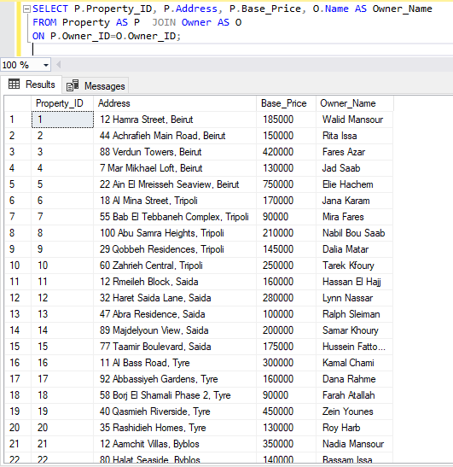
Question 1
Retrieve each property’s ID, address, base price, and the name of its owner.
SELECT P.Property_ID, P.Address, P.Base_Price, O.Name AS Owner_Name
FROM Property AS P JOIN Owner AS O
ON P.Owner_ID=O.Owner_ID;

Explanation:
This query joins the Property table with the Owner table to match each property with the correct owner. We use the Owner_ID key that exists in both tables to connect them and show combined information.

Query 2 – Property Location and Type (JOIN with 3 Tables)
Question 2
Retrieve each property’s address, city, area name, and property type.

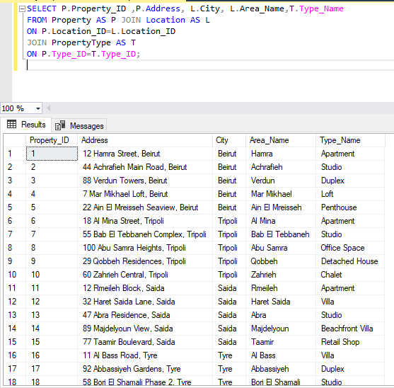
SELECT P.Property_ID ,P.Address, L.City, L.Area_Name,T.Type_Name
FROM Property AS P JOIN Location AS L
ON P.Location_ID=L.Location_ID
JOIN PropertyType AS T
ON P.Type_ID=T.Type_ID;

Explanation:
This query joins three tables to show full details about every property: where it is located and what type it is. We combine location data and type data with the property table.

Query 3 – Properties with Optional Sale Information (LEFT JOIN)
Question 3
List all properties with their sale price and sale date if sold.

SELECT P.Property_ID,P.Address,P.Status,S.Sale_Price,S.Sale_Date
FROM Property AS P LEFT JOIN Listing AS L
ON P.Property_ID = L.Property_ID
LEFT JOIN Sale AS S
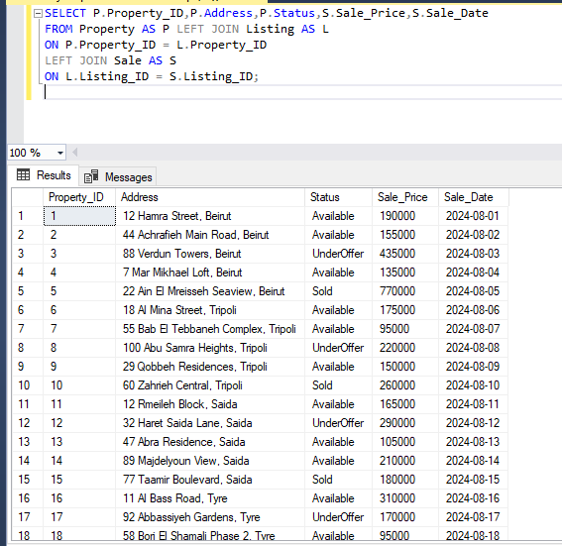
ON L.Listing_ID = S.Listing_ID;

Explanation:
We use a LEFT JOIN so all properties appear, even if no sale exists. If a property was sold, the sale price and date will be shown; otherwise they remain NULL.

Query 4- Listings with agent information (RIGHT JOIN)
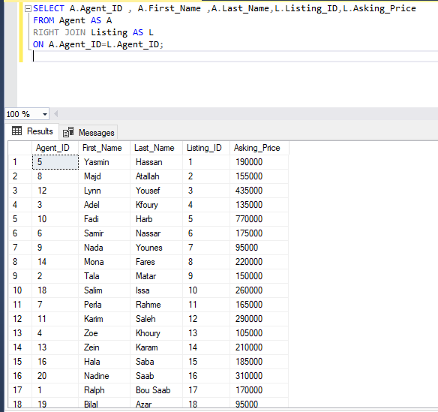
Question 4
Retrieve all listings along with their agent name.
SELECT A.Agent_ID , A.First_Name ,A.Last_Name,L.Listing_ID,L.Asking_Price
FROM Agent AS A
RIGHT JOIN Listing AS L
ON A.Agent_ID=L.Agent_ID;

Explanation:
A RIGHT JOIN ensures all listings are shown, even if an agent is missing. It connects listings to the agents handling them.

Query 5 – Number of properties per city (GROUP BY)
Question 5:
Count how many properties exist in each city.
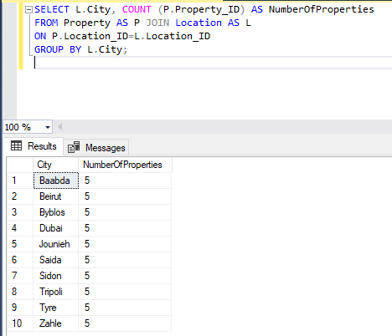
SELECT L.City, COUNT (P.Property_ID) AS NumberOfProperties
FROM Property AS P JOIN Location AS L
ON P.Location_ID=L.Location_ID
GROUP BY L.City;

Explanation:
This query groups all properties by city and counts them. It summarizes how many properties are available in each location.

Query 6 – Agents with over 3 active listings
Question 6:
Retreve agents who have more than three active listings.

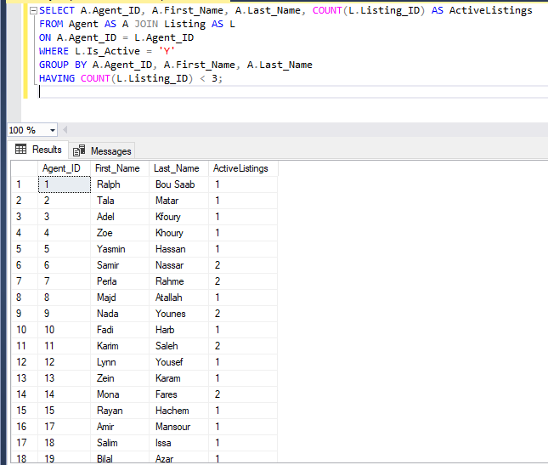
SELECT A.Agent_ID, A.First_Name, A.Last_Name, COUNT(L.Listing_ID) AS ActiveListings
FROM Agent AS A JOIN Listing AS L
ON A.Agent_ID = L.Agent_ID
WHERE L.Is_Active = 'Y'
GROUP BY A.Agent_ID, A.First_Name, A.Last_Name
HAVING COUNT(L.Listing_ID) < 3;

Explanation:
This SQL query retrieves all agents who currently have fewer than 3 active property listings. It joins the Agent table with the Listing table using the Agent_ID, filters only listings marked as active (Is_Active = 'Y'), then groups the results by each agent. The COUNT() function calculates how many active listings each agent has, and the HAVING clause selects only those with less than 3 active listings. This helps identify agents with a low active workload.

Query 7 – Listings with property and owner
Question 7
List all listings with the property address and the owner name (through Listing → Property → Owner).
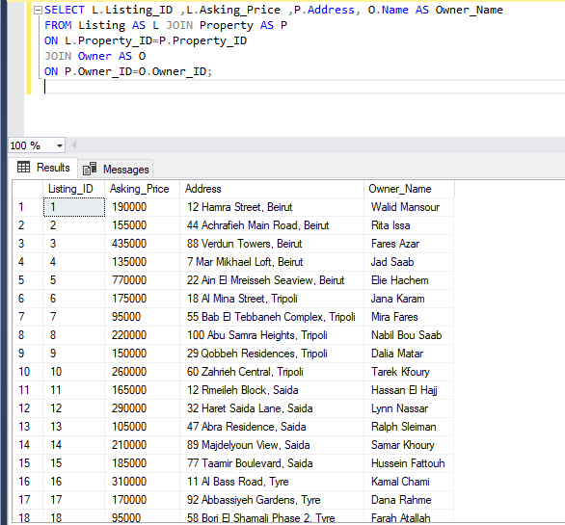
SELECT L.Listing_ID ,L.Asking_Price ,P.Address, O.Name AS Owner_Name
FROM Listing AS L JOIN Property AS P
ON L.Property_ID=P.Property_ID
JOIN Owner AS O
ON P.Owner_ID=O.Owner_ID;

Explanation:
This query joins Listing with Property and Owner to show each listing together with the property address and the name of the owner who owns that property.

Query 8 – Offers with buyer and city (JOIN + ORDER BY)
Question 8
Show all offers with the buyer name and the city of the property, ordered by offer price from highest to lowest.
SELECT O.Offer_ID,B.Name AS Buyer_Name,L.Listing_ID,O.Offer_Price,LC.City
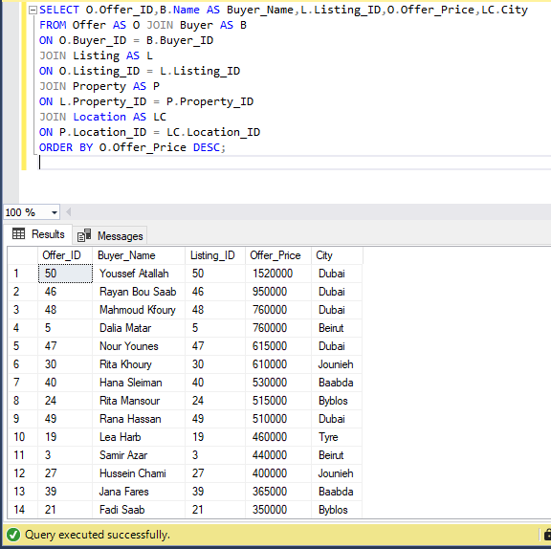
FROM Offer AS O JOIN Buyer AS B
ON O.Buyer_ID = B.Buyer_ID
JOIN Listing AS L
ON O.Listing_ID = L.Listing_ID
JOIN Property AS P
ON L.Property_ID = P.Property_ID
JOIN Location AS LC
ON P.Location_ID = LC.Location_ID
ORDER BY O.Offer_Price DESC;

Explanation:
This query joins the offer with the buyer and the property’s location to see who made each offer and in which city the property is located. The result is ordered by the offered price from highest to lowest using ORDER BY

Query 9 – Active listings with agent details
Question 9
List all active listings with the property address and the agent’s name.
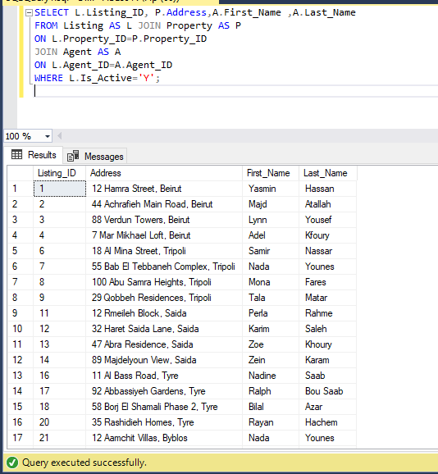
SELECT L.Listing_ID, P.Address,A.First_Name ,A.Last_Name
FROM Listing AS L JOIN Property AS P
ON L.Property_ID=P.Property_ID
JOIN Agent AS A
ON L.Agent_ID=A.Agent_ID
WHERE L.Is_Active='Y';

Explanation:
This query joins Listing, Property, and Agent and filters only active listings (IsActive = 'Y'). It shows which agent is currently responsible for each active listing.

Query 10 – Payments with buyer and amount (JOIN + aggregate per sale not needed)
Question 10
Display all payment records with the buyer name, sale ID, payment date, amount, and method.
SELECT Py.Sale_ID,B.Name AS Buyer_Name,Py.Payment_No,Py.Payment_Date,Py.Amount,Py.Method
FROM Payment AS Py JOIN Sale AS S
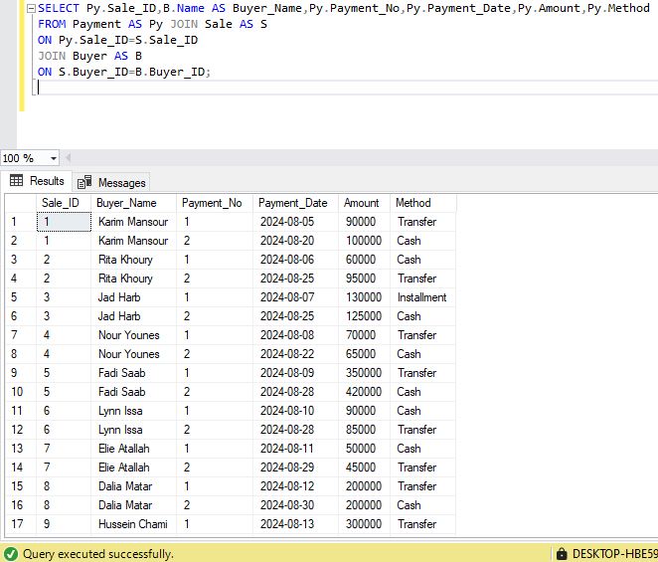
ON Py.Sale_ID=S.Sale_ID
JOIN Buyer AS B
ON S.Buyer_ID=B.Buyer_ID;

Explanation:
This query joins Payment with Sale and Buyer to show each payment for a sale, identifying which buyer made it and how they paid.

Query 11 – Buyers who made offers but none accepted yet (EXISTS / NOT EXISTS)
Question 11
Find buyers who have made at least one offer but do not have any accepted offer.
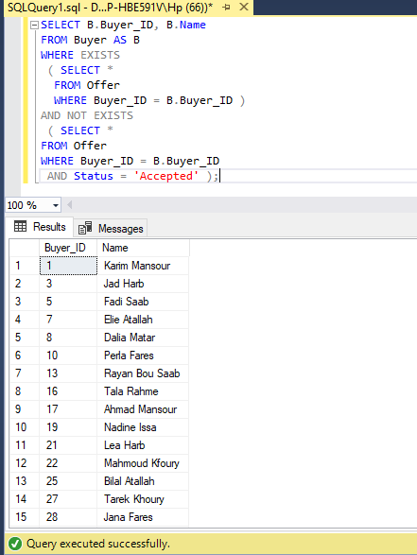
SELECT B.Buyer_ID, B.Name
FROM Buyer AS B
WHERE EXISTS
( SELECT *
FROM Offer
WHERE Buyer_ID = B.Buyer_ID )
AND NOT EXISTS
( SELECT *
FROM Offer
WHERE Buyer_ID = B.Buyer_ID
AND Status = 'Accepted' );

Explanation:
The first EXISTS ensures the buyer has made at least one offer. The second NOT EXISTS checks that none of their offers has status 'Accepted'. Together, we get buyers who tried to buy but still have no accepted deal.

Query 12 – Agents with at least one active listing (GROUP BY + HAVING)
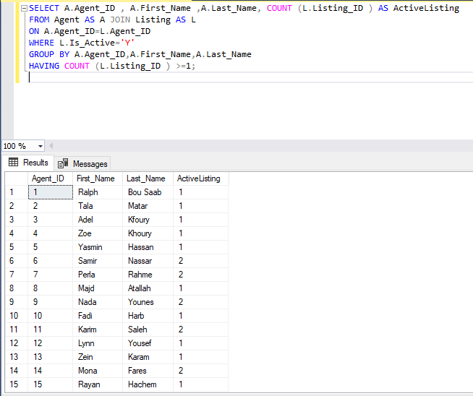
Question 12
Find all agents who have at least one active listing, and show how many active listings each one has.
SELECT A.Agent_ID , A.First_Name ,A.Last_Name, COUNT (L.Listing_ID ) AS ActiveListing
FROM Agent AS A JOIN Listing AS L
ON A.Agent_ID=L.Agent_ID
WHERE L.Is_Active='Y'
GROUP BY A.Agent_ID,A.First_Name,A.Last_Name
HAVING COUNT (L.Listing_ID ) >=1;

Explanation :
This query joins the Agent and Listing tables and filters only listings that are active (IsActive = 'Y'). It then groups the rows by agent and counts how many active listings each agent has. The HAVING COUNT(L.Listing_ID) >= 1 condition keeps only agents who have at least one active listing.

Query 13 – Highest sale price and buyer (nested query )
Question 13
Find the highest sale price and the buyer who purchased that property.
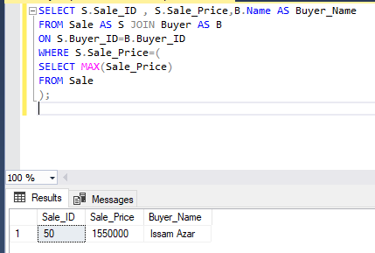
SELECT S.Sale_ID , S.Sale_Price,B.Name AS Buyer_Name
FROM Sale AS S JOIN Buyer AS B
ON S.Buyer_ID=B.Buyer_ID
WHERE S.Sale_Price=(
SELECT MAX(Sale_Price)
FROM Sale
);

Explanation:
The subquery calculates the maximum sale price across all sales. The outer query then selects the sale (or sales) whose Sale_Price matches that maximum and joins it with the buyer.

Query 14 – Properties above the average base price (nested query)
Question 14
List all properties whose base price is above the average base price of all properties.
SELECT P.Property_ID, P.Address, P.Base_Price
FROM Property AS P
WHERE P.Base_Price>(
SELECT AVG(Base_Price)
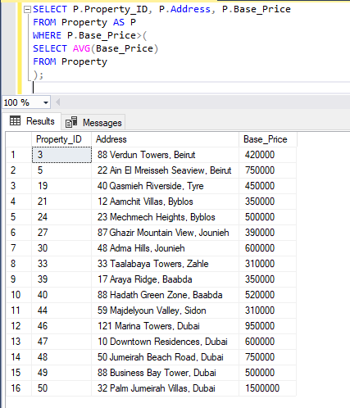
FROM Property
);

Explanation:
The inner query computes the overall average base price, and the outer query filters properties whose base price is greater than that value. It is another example of a nested subquery.

Query 15 – total amount of payments made by each buyer (JOIN , GROUP BY , ORDER BY )
Question 15
Show the total amount of payments made by each buyer, and order the buyers from the highest total paid to lowest .
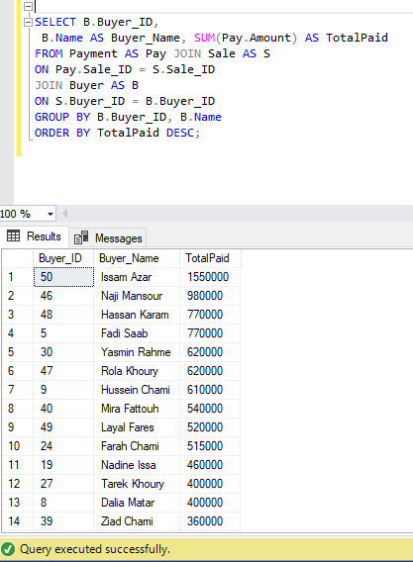
SELECT B.Buyer_ID,
B.Name AS Buyer_Name, SUM(Pay.Amount) AS TotalPaid
FROM Payment AS Pay JOIN Sale AS S
ON Pay.Sale_ID = S.Sale_ID
JOIN Buyer AS B
ON S.Buyer_ID = B.Buyer_ID
GROUP BY B.Buyer_ID, B.Name
ORDER BY TotalPaid DESC;

Explanation:
This query calculates the total amount of payments made by each buyer. It joins the Payment, Sale, and Buyer tables to link each payment back to the buyer who made it. The SUM() function adds all payment amounts for each buyer, and the results are grouped by the buyer's ID and name. Finally, the query orders the buyers from the highest total amount paid to the lowest using ORDER BY TotalPaid DESC.

Query Diversity Summary
The set of 15 queries covers a wide range of SQL features required by the project:
- Joins: Regular JOIN as well as LEFT JOIN and RIGHT JOIN
- Aggregate functions: COUNT, MAX, AVG
- Grouping and filtering: GROUP BY and HAVING
- Ordering: use of ORDER BY for sorting results
- Nested subqueries: queries using subqueries in WHERE to compare with aggregate values
- EXISTS / NOT EXISTS: queries that check for the existence or non-existence of related records
Together, these queries demonstrate that the database design supports realistic business questions and complex data retrieval operations in the real estate domain.

Functional Dependencies (FDs)
In this section, we identify the main Functional Dependencies (FDs) for each relation in the Real Estate Management System. Functional Dependencies describe how one attribute (or a set of attributes) uniquely determines other attributes in the same table. They are important for checking normalization, reducing redundancy, and ensuring data consistency.

OWNER
Owner(Owner_ID, Name, Phone, Email, City)
FDs: Owner_ID → Name, Phone, Email, City
Primary key: Owner_ID

LOCATION
Location(Location_ID, City, Area_Name)
FDs: Location_ID → City, Area_Name
Primary key: Location_ID

PROPERTY TYPE
PropertyType(Type_ID, Type_Name)
FDs: Type_ID → Type_Name
Primary key: Type_ID

AGENT
Agent(Agent_ID, First_Name, Last_Name, Phone, Email)
FDs: Agent_ID → First_Name, Last_Name, Phone, Email
(Primary key: Agent_ID)

BUYER
Buyer(Buyer_ID, Name, Email, City, Budget_Min, Budget_Max)
FDs: Buyer_ID → Name, Email, City, Budget_Min, Budget_Max
Primary key: Buyer_ID

PROPERTY
Property(Property_ID, Address, Size_SQM, Bedrooms, Bathrooms, Base_Price, Status, Owner_ID, Location_ID, Type_ID)
FDs: Property_ID → Address, Size_SQM, Bedrooms, Bathrooms, Base_Price, Status, Owner_ID, Location_ID, Type_ID
Primary key: Property_ID

Listing
Listing(Listing_ID, Property_ID, Agent_ID, List_Date, Asking_Price, Commission_Rate, IsActive)
FDs: Listing_ID → Property_ID, Agent_ID, List_Date, Asking_Price, Commission_Rate, IsActive
Primary key: Listing_ID

OFFER
Offer(Offer_ID, Listing_ID, Buyer_ID, Offer_Price, Offer_Date, Status)
FDs: Offer_ID → Listing_ID, Buyer_ID, Offer_Price, Offer_Date, Status
Primary key: Offer_ID

SALE
Sale(Sale_ID, Listing_ID, Buyer_ID, Sale_Date, Sale_Price)
FDs: Sale_ID → Listing_ID, Buyer_ID, Sale_Date, Sale_Price
Primary key: Sale_ID

PAYMENT (Weak Entity)
Payment(Sale_ID, Payment_No, Payment_Date, Amount, Method)
FDs: (Sale_ID, Payment_No) → Payment_Date, Amount, Method
Primary key: (Sale_ID, Payment_No)

Relational Algebra

Question 1 — Retrieve the Listing ID, Property Address, Agent ID, and Asking Price for all listings.
Relational Algebra
$π$Listing_ID,Address,Agent_ID,Asking_Price (Listing ⋈ Property)

Explanation
A natural join combines Listing with Property using Property_ID, then projection returns the required attributes.

Question 2 — Retrieve properties with base price greater than 300,000
Relational Algebra
Π_{Property_ID,Base_Price,Address}(𝜎 _{Base_Price > 300000}(Property))

Explanation
This expression first applies a selection on the Property Table to keep only the properties where Base_Price is greater than 300000.After filtering , a projection is used to display only the Property_ID and Base_price attributes. This produces a concise list of expensive properties without including any extra columns .

Question 3 — Retrieve the Buyer ID and Name of all buyers who live in the city “Beirut”
Relational Algebra
(Since Buyer table already contains their City directly, we do not need joins.)
Π_{Buyer_ID,Name}(𝜎 _{City=’Beirut’} (Buyer))

Explanation
This expression filters the Buyer table to keep only buyers whose city is”Beirut” using a selection operation . After filtering, a projection is applied to return only the buyer_ID and Name of those buyers. This produces a clean list of all buyers who live in Beirut

Question 4 — Find all properties that have never received an offer
Relational Algebra
Π_{Property_ID,Address}(Property) – Π_{Property_ID,Address}(Property ⋈ Listing ⋈ Offer)

Explanation
The first expression retrieves all properties in the system, while the second expression retrieves only those properties that have at least one offer associated with them through the Listing and Offer relations. By applying the set-difference operation, we obtain the properties that appear in the first set but not in the second—meaning these properties have never received any offers.

Conclusion
The Real Estate Management System developed in this project demonstrates how database technologies can be effectively used to organize, track, and manage complex real-world operations. By analyzing the domain carefully, identifying the key entities and relationships, and constructing a complete EER model, the system provides a structured and accurate representation of real estate activities such as property listing, buyer interaction, offers, sales, and payments.
The conversion of the EER diagram into a fully normalized relational schema ensures data consistency, eliminates redundancy, and supports reliable data storage. The SQL implementation, including table creation, constraints, and sample data insertion, shows how the design can be translated into a functioning database. The execution of 15 diverse SQL queries—covering joins, aggregate functions, groupings, nested queries, and existence-based conditions—demonstrates the flexibility and analytical power of the system in answering meaningful business questions.
Furthermore, documenting the functional dependencies and relational algebra expressions highlights the system’s strong theoretical foundation and confirms that the database adheres to normalization principles and integrity constraints. Overall, this project shows how a well-designed database can improve efficiency, support decision-making, and streamline operations in the real estate industry. It also reinforces the importance of structured data models and SQL querying skills in solving real-world problems and developing scalable digital solutions.

